Unit 12

HVTN Local Site Materials

This document contains examples of logos, slogans and educational/outreach materials from HVTN clinical research sites over the years. They may not represent materials that are currently in use.

**ATLANTA, GEORGIA:** The Hope clinic at Emory used the “Tops & Bottoms” campaign to help recruit for HVTN 505. The provocative images were used to help attract their target study population.

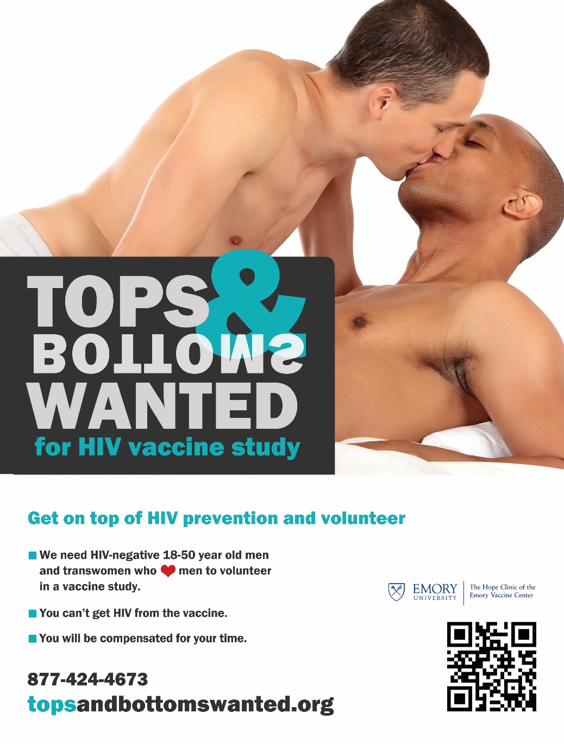

**ANNANDALE, VIRGINIA**

The CARE ID research site chose to use the “Stand up for Love” campaign on their recruitment materials. This one features a transgender model to help signify inclusion and recruitment of transgender women.

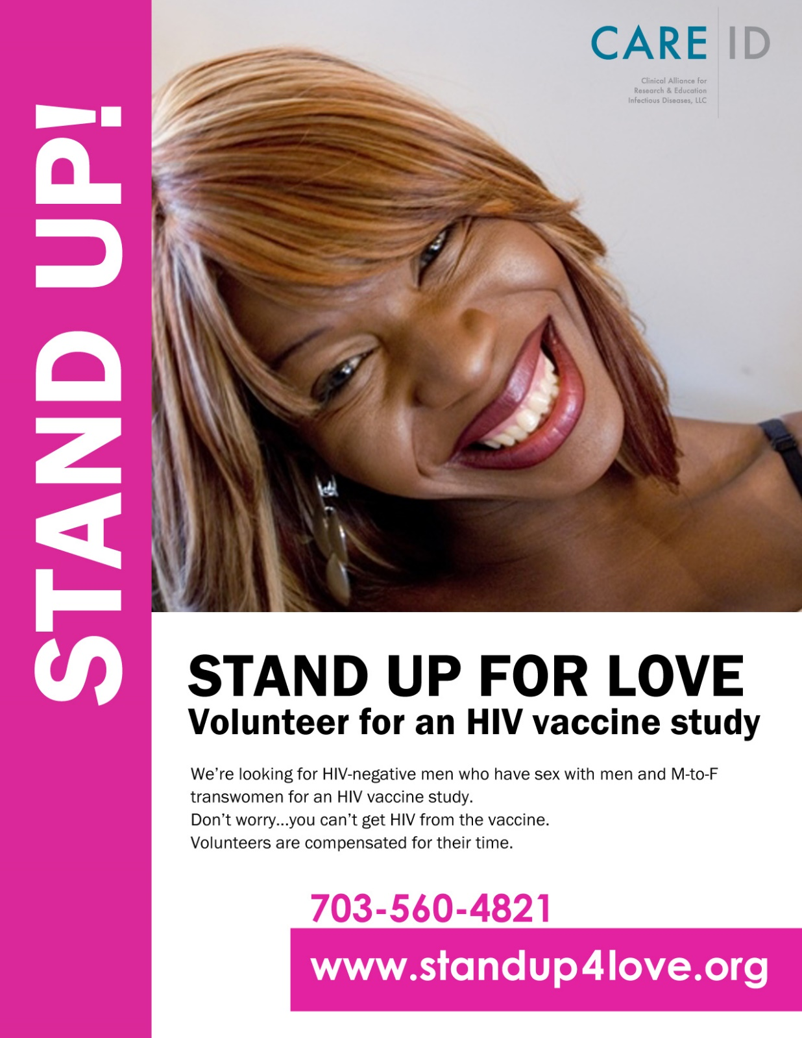

**LIMA, PERU:** The Impacta site creates a colorful monthly publication to help support their outreach efforts. They also have created the “Vacuman” super hero who is featured on their materials, on their facebook page and in-person at outreach events.

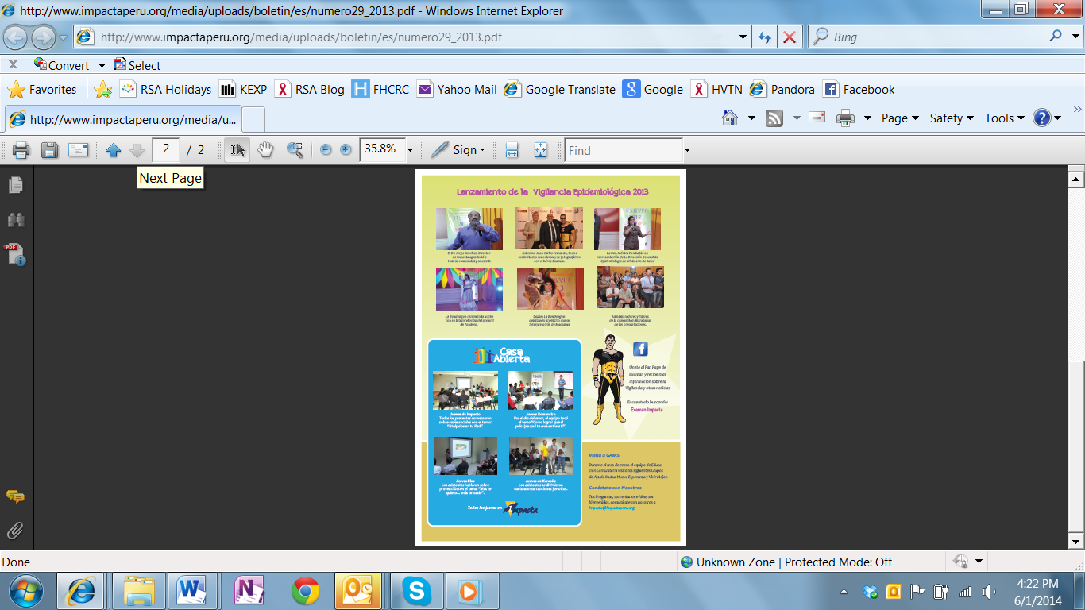

VACUMAN

**DURBAN, SOUTH AFRICA:** Our CAPRISA eThekwini site uses colorful posters with bold images and simple clear messages to help reach out to former study volunteers.



**IQUITOS, PERU:** The CAB created their own attractive brochure to promote and attract new potential CAB members.

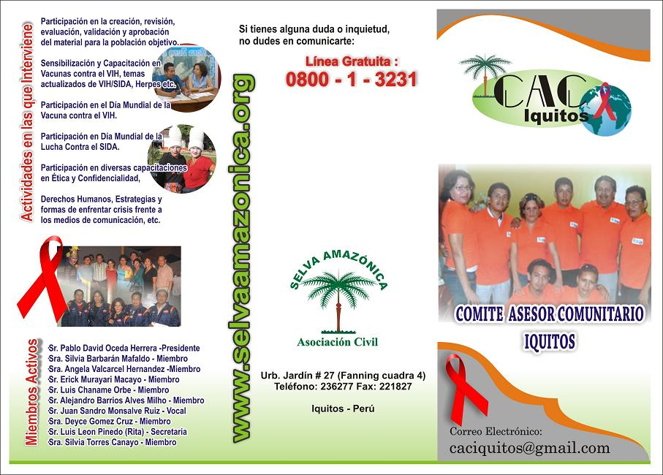

**San Francisco, California:** The Bridge HIV site got feedback from their community that they wanted to see pictures of actual study volunteers, not models or stock photos purchased from a website. They developed a campaign featuring about 8 past participants. All of the materials had the same text, except for the unique details about each person. (Some of the scanned images are crooked.)

Text on the back of the card:

